Information on tourist spots around Ojiya
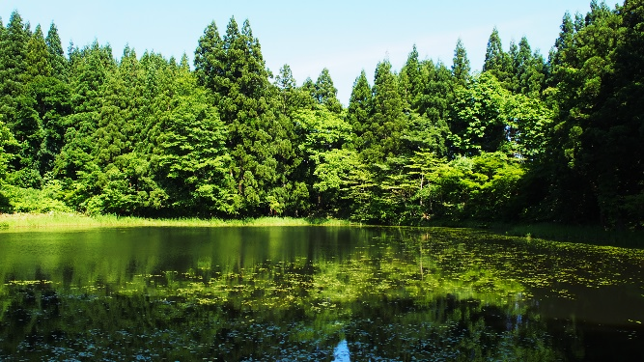

Kōōridonnoike (Kōōridon Pond)

It is located in Higashiyoshidani which is 230m above sea level, and its size is about 70 acres.

There are about 20 floating islands made of reed and rabbit-ear iris. The pond is inhabited by creatures, such as rhacophorus arboreus and many kinds of dragonflies. It is also a habitat of plants, such as cinnamon fern and bogbean.

In 1953, the Association of the Preservation of Kōōridonnoike was established in order to maintain and preserve the pond.
In 1956, it was designated as a cultural property by Ojiya city. Later in 2004, it was designated as a natural monument by the prefecture of Niigata.

The pond has been believed to be the God of Water by the local people and thus mysterious legends have been passed down:
- A grandfather who teased a snake at the pond said to the snake, “I’ll give you my grandson when he gets older, so please forgive me”. Years later, when the grandson was on a boat with several other passengers in the Shinano river, which is connected to Kōōridonnoike, it suddenly stopped. After a moment of quietness, a voice out of nowhere stated, “There is a person on this boat whom to be sacrificed to the God of Kōōridonnoike.” With no hesitation the grandson threw himself off the boat into the water as though he was possessed. Soon after, a giant snake appeared from under the water holding the grandson. The giant snake slowly disappeared back into the dark water and the grandson was never to be seen again.
- When the locals were having a festival praying for a good harvest, a man came saying, “I killed three cats and threw them into the pond to surprise the guardian spirit of the pond. A rice dealer from a different town asked me to do it, so that a storm would come and the price of rice increases.” Soon after, a storm came, and all the fields were inundated. Day after the storm, the water had dried out and the man was found dead decapitated.

